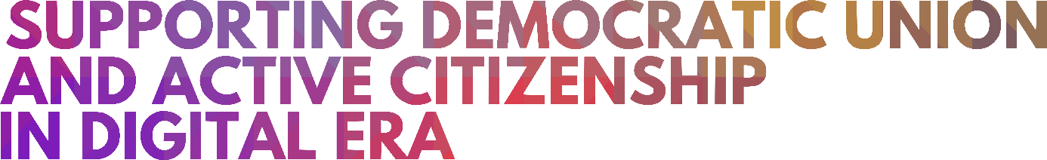
PENNE, ITALY
4-7 FEBRUARY 2020
1ST INTERNATIONAL EVENT

"IS IT ALREADY A DIGITAL DEMOCRACY?" - ON TECHNOLOGICAL DEVELOPMENTS
AND HOW THEY SHAPE DEMOCRACY
SUMMARY OF THE INTERVENTION

SPEAKER: Lawyer Mr Sandro Di Minco - professor in the Master in Computer Law at the University "La Sapienza" in Rome

I would say that there are no rules that are missing but there are many rules that should be given effectiveness. The real problem is therefore not that of having new rules because we have enough of them. We do not sufficiently have the correct and complete implementation of this legislation. There is a problem both an awareness on the part of digital rights holders, which are recognized by very important rules of European and national rank, and on the other hand a tendency in general of the Italian public administration to be somewhat distracted in correct application of these rules. Unfortunately, Italy in the European ranking from the latest data relating to December 2019 is in the fifth last place on the digitization levels in Europe and alas Abruzzo ranks in Italy in the third last place from the point of view of the digitization level while, and at the same time it should be emphasized, the Abruzzo Regione is placed at very high levels in the use of social networks. Here there is obviously a contradiction: there is no attitude of the citizen of refusal in the face of technologies since he/she uses them for social media. It is probably not adequately facilitated in the use of information technologies (IT) for the purpose, however, in accessing to the important public services. It is as we have citizens who know how to use the car but use it or know how to use it only to go on holiday to the beach and then go to work with the mule. It is a paradox of this type because it would be necessary to create the conditions for information technologies (IT) to be used as well as national and European standards provide, for the benefit of citizens to be able to participate in democratic life in a more direct and active way, to be able to exercise control more direct and active than the methods of use of public resources by the Italian public administration and to be able to exercise a whole series of rights both towards public administrations and towards private individuals who manage public services using digital identity, electronic (digital) signatures, tools and standards that the European and national regulatory framework has made available to us for many years.

